|  |  |  |  |
| --- | --- | --- | --- |
| **PnL Type** | **Definition** | **Key Use** | **Example** |
| **Clean PnL** | Excludes non-trading factors (fees, funding) | Evaluates trading performance | Measures only profits from active trades, not fees. |
| **Hypothetical PnL** | PnL without new trades, based on market changes | Isolates market impact | Portfolio PnL if no trades were executed today. |
| **Volcker PnL** | Separates client-oriented vs. speculative trades | Regulatory compliance (Volcker Rule) | Monitors if PnL comes from market-making or speculation. |
| **Books PnL** | Aggregates PnL across specific portfolios | Tracks desk/strategy performance | Equity vs. Fixed Income desk PnL comparisons. |
| **VaR PnL** | Theoretical PnL based on VaR model | Assesses risk and model accuracy | Validates if losses exceed predicted VaR limits. |

**Define Clear PnL Types**

Start by formally defining the rules and inputs for each PnL type to ensure consistency and clarity. This will help you establish what data and calculations are necessary for each PnL metric.

* **Clean PnL**: Profit and loss derived purely from trading activity, excluding external factors like funding, fees, or market fluctuations.
* **Hypothetical PnL**: PnL calculated assuming no new trades were made and based solely on market movements affecting previously held positions.
* **Books PnL**: Aggregated PnL for specific trading books or portfolios.
* **Rerecord PnL**: The difference between booked PnL and corrected PnL after adjustments (e.g., pricing corrections or trade entry mistakes).
* **GL (General Ledger) PnL**: PnL booked in the financial system that flows into accounting for reporting purposes.
* **VaR PnL**: PnL derived from Value at Risk calculations, reflecting the risk exposure and potential losses within a defined confidence interval.
* **Volcker PnL**: PnL calculated for compliance with the Volcker Rule, separating client-related profits from proprietary trading activities.

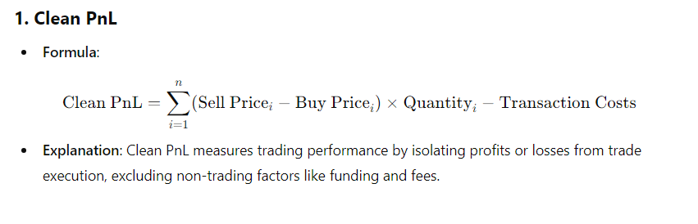

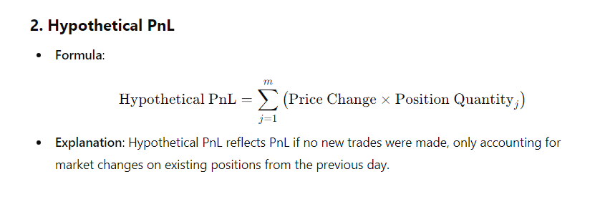

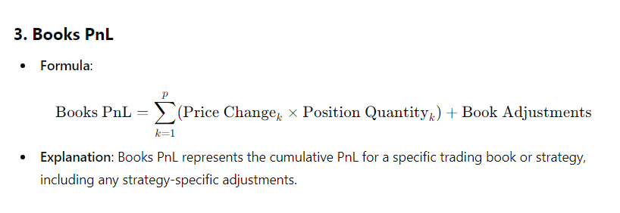`

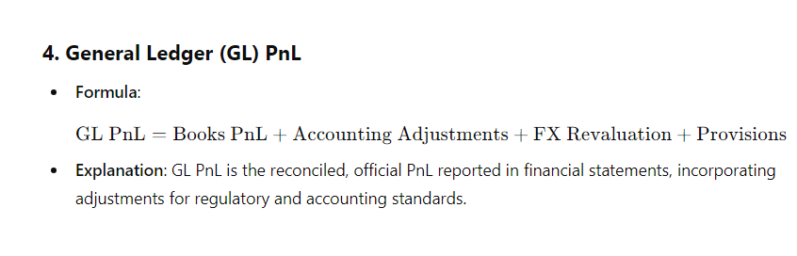

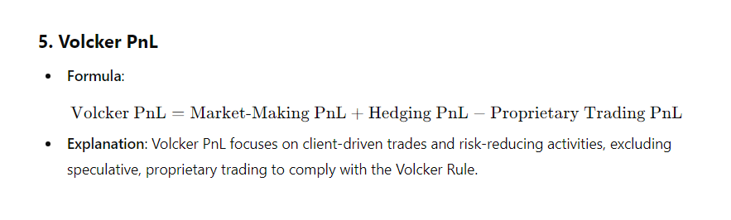

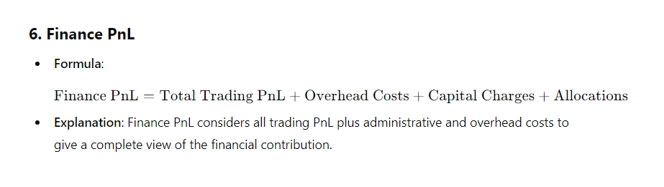

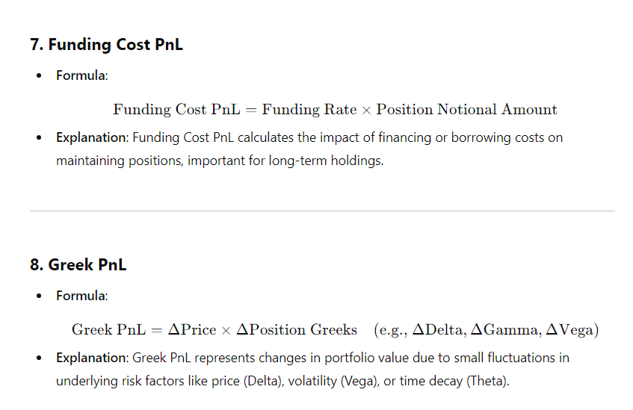

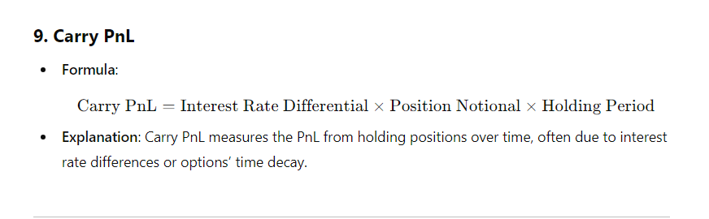

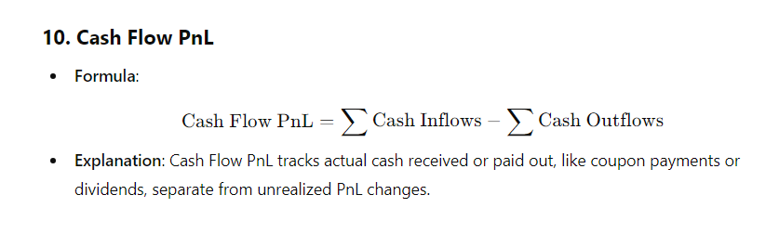

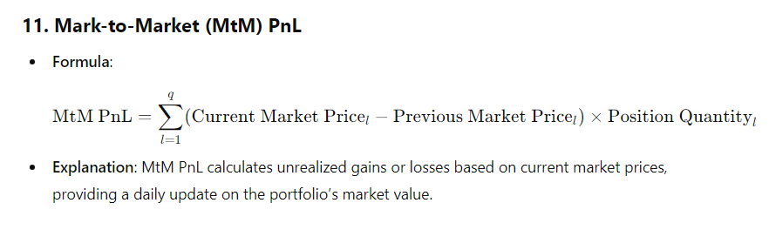

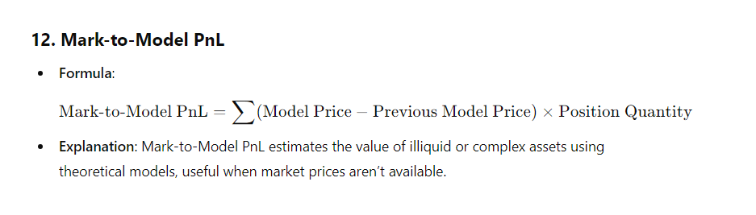

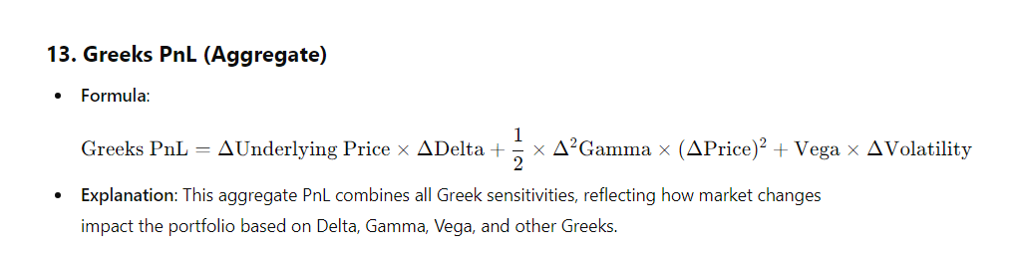

**Data Collection and Sources**

Identify the data sources needed to calculate each type of PnL:

* **Market Data**: Real-time prices, bid-ask spreads, and historical data.
* **Trade Data**: Transactions, execution details, timestamps.
* **Risk Factors**: Volatility, interest rates, currency rates, correlations.
* **Reference Data**: Security master files, identifiers (ISIN, CUSIP).
* **Accounting Data**: For GL PnL, access to financial systems or general ledger entries.

**Build the PnL Calculation Modules**

For each PnL type, build a distinct calculation module that uses the appropriate inputs and adheres to the rules you’ve defined. Each module will handle the following:

* **Clean PnL**: Calculate daily PnL based on trading activity, excluding external market moves or non-trading factors like fees.
* **Hypothetical PnL**: Calculate what the PnL would be assuming no new trades occurred, only considering changes in market prices.
* **Books PnL**: Aggregate the PnL across a specific trading book or portfolio.
* **Rerecord PnL**: Track changes to PnL based on corrections to trades or market data.
* **GL PnL**: Ensure the PnL is aligned with the general ledger entries and is ready for financial reporting.
* **VaR PnL**: Derive PnL from risk factor changes as calculated by the VaR model (e.g., market shocks).
* **Volcker PnL**: Segment the PnL based on client-oriented trades vs. proprietary trades for compliance with the Volcker Rule.

**Implement Differentiation Logic**

To differentiate between the PnL types, introduce logic into the framework that governs when and how each type is calculated and used.

* **Scenario-based Differentiation**: For example, Hypothetical PnL will ignore new trades and use prior day positions, while Clean PnL will include the impact of new trades.
* **Data Filtering**: For GL PnL, ensure only booked trades and officially reconciled data are used, while for Books PnL, all trading book entries are considered.
* **Risk-based Differentiation**: VaR PnL focuses on scenarios generated by the VaR model (simulating losses under risk conditions), while Volcker PnL focuses on isolating speculative trades.

**Build a Centralized PnL Engine**

Create a centralized engine that can handle multiple PnL calculations in parallel. This engine will:

* **Ingest Data**: Pull market, trade, and accounting data from all necessary sources.
* **Execute PnL Calculations**: Apply the correct PnL calculation based on the type.
* **Track Historical PnL**: Store historical PnL calculations for comparison, auditing, and regulatory reporting.

**1. Clean PnL**

* **Definition**: Clean PnL isolates the impact of trading decisions by stripping out non-trading factors such as funding, fees, and overnight risks.
* **Purpose**: To focus on the performance of traders and strategies without external or market-related noise.
* **Use Case**: Used for evaluating a trader’s skill based on pure trading activities.
* **Example**: Excludes the effect of market movements between close and open (overnight gaps) or any transaction costs.

**Hypothetical PnL**

* **Definition**: Hypothetical PnL represents the profit or loss if positions were held constant (without new trades or changes) over a given period, such as from the previous day’s closing positions.
* **Purpose**: Used to measure how much of the PnL is due to market movements, independent of trading activity.
* **Use Case**: In stress testing and VaR calculations to determine how market changes affect positions.
* **Example**: Assume that if the trader didn’t make any new trades, the portfolio’s hypothetical PnL would reflect how much the market movements alone impacted the portfolio.

**Volcker PnL**

* **Definition**: Volcker PnL refers to profit or loss calculations that comply with the **Volcker Rule**, part of the Dodd-Frank Act, which limits proprietary trading by banks.
* **Purpose**: Used to ensure compliance by separating market-making activities from speculative proprietary trading.
* **Use Case**: Monitors whether PnL arises from client-oriented trades (allowed) or speculative trades (prohibited).
* **Example**: A breakdown of Volcker PnL might show which profits came from spreads in client transactions versus speculative bets on market movements.

**Books PnL**

* **Definition**: Books PnL refers to the PnL aggregated across specific trading books or portfolios, providing insight into the performance of a particular business line or strategy.
* **Purpose**: Tracks PnL across different desks, trading strategies, or portfolios.
* **Use Case**: Used in internal management reporting to monitor the profitability of different trading books and for budget allocation.
* **Example**: The equity trading desk’s book PnL might differ from the fixed-income desk’s PnL due to the specific instruments they trade.

**Value at Risk (VaR) PnL**

* **Definition**: VaR PnL is the theoretical PnL predicted by the **Value at Risk (VaR)** model, which estimates the maximum expected loss over a specific time horizon at a given confidence level.
* **Purpose**: To assess the potential downside risk of a portfolio.
* **Use Case**: Used in risk management to compare actual PnL to the predicted loss threshold to validate the VaR model.
* **Example**: If a 1-day VaR is $1 million at 95% confidence, the actual PnL should only exceed this amount in 5 out of 100 days.

The **Volcker Rule** is a part of a set of laws designed to help prevent banks from taking too many risks with other people's money. Imagine you're at school and you have a big jar of candy that your friends have given you to hold. You promised your friends you would only use the candy for special events, like birthday parties or school events. But one day, you decide to take some candy from the jar to eat for yourself. This could cause problems because now your friends might not have enough candy for the events they planned.

Let’s pick an **Interest Rate Swap (IRS) desk** as an example and show the **methodology and function** used to compute the **Volcker PnL** for this desk. Interest Rate Swap desks trade swaps, options, and other derivatives that hedge or speculate on movements in interest rates.

**Data Inputs** The IRS desk will have various inputs, including trade data, market data, risk factor sensitivities, and position data. Key inputs include:

* **Trade Data**: Each executed trade includes notional amount, swap rates, maturities, and counterparties.
* **Market Data**: Interest rate curves (e.g., LIBOR, SOFR), yield curves, discount factors, and swaption volatilities.
* **Risk Factor Sensitivities**: DV01 (Delta Value of a 1-basis-point change in interest rates), PV01 (Price Value of a 1-basis-point change), Vega (sensitivity to volatility), and Gamma (second-order risk).
* **Position Data**: Current open positions for each swap or derivative.
* **PnL Adjustments**: Fees, funding costs, and adjustments related to accounting rules (clean PnL excludes these).

1. Compute Market-Making PnL

Market-Making PnL=i=1∑n​(Trade Pricei​−Mid-Market Price)×Notional Amounti​

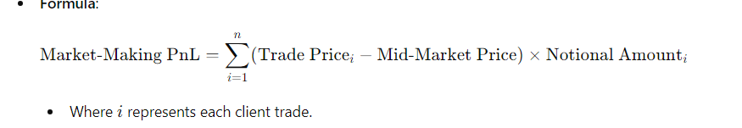

This includes all PnL from facilitating client trades in interest rate swaps and related derivatives.

* **Inputs**:
  + Trade data (client transactions, notional, rate, and maturity)
  + Market data (swap rates, discount curves)
  + Bid-ask spreads
* **Method**:
  + For each client transaction, calculate the profit or loss from buying at one rate and selling at another (the bid-ask spread).
  + Consider changes in the market rates during the holding period and any adjustments based on trade execution costs.

2. Compute Hedging PnL

• **Inputs**:

* Current position data (open interest rate swap positions)
* Market data (interest rate curve shifts, yield curve changes)
* Risk sensitivities (DV01, PV01, Vega)

• **Method**:

* Calculate the change in the value of hedging positions as interest rates or volatilities shift, using DV01 or Vega.
* Ensure that each hedging trade can be traced back to a specific risk being hedged.

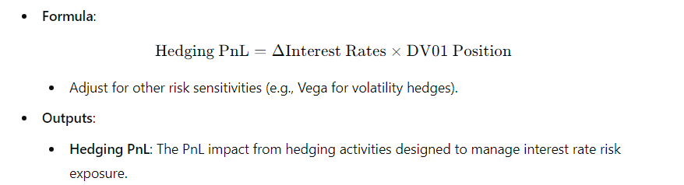

**3.Exclude Proprietary Trading PnL**

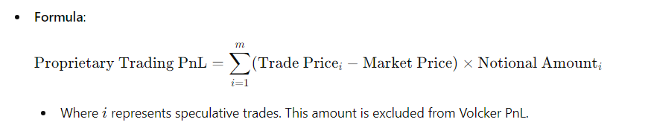

identify and exclude any trades that are speculative (i.e., trades that do not support client activities or hedging). This is the critical step to comply with the Volcker Rule.

* **Inputs**:
  + Holding period (proprietary trades are typically short-term).
  + Attribution of trades to clients vs. non-client (proprietary) activities.
* **Method**:
  + Flag any trades that are not directly linked to client demand or risk hedging as proprietary.
  + Exclude the PnL from proprietary trades from the final Volcker PnL.

4. Compute Clean PnL



Clean PnL focuses on profits purely from trading activities, excluding non-trading factors like funding, liquidity costs, and fees.

* **Inputs**:
  + Trade data (execution prices, market prices)
  + Risk data (DV01, PV01)
  + Market data (interest rate changes)
* **Method**:
  + Calculate PnL from trading activities, ignoring any overnight market movements, funding costs, and other non-trading expenses.

For a bank managing over a trillion dollars in assets and a complex structure with over 1 million positions across 50 subdesks, managing and calculating different PnLs requires a robust, scalable, and efficient approach. Here’s a suggested framework to handle this complexity:

**1. Centralized Data Warehouse with Real-Time Data Processing**

* **Centralized Data Storage**: Create a data warehouse to store all trade, market, and position data. Use a scalable, cloud-based infrastructure (e.g., AWS Redshift, Google BigQuery, or Azure Synapse) to accommodate the volume and frequency of data.
* **Real-Time Data Ingestion**: Implement data pipelines using tools like Apache Kafka, Spark, or Flink for real-time data ingestion and processing, ensuring that data updates (market prices, trade executions, etc.) are available across the bank's desks instantly.
* **Data Governance and Consistency**: Implement strict data governance policies to maintain data quality, consistency, and timeliness across all subdesks, which is essential for accurate PnL calculations.

**2. Modular PnL Calculation Framework**

* **PnL Calculation Engine**: Develop a modular PnL calculation engine that can handle different PnL types in parallel. Each PnL type (e.g., Clean, Hypothetical, Volcker, Books, GL) should be a module within this engine.
* **Microservices Architecture**: Implement the PnL calculation engine using microservices, where each PnL type is calculated independently. This allows for better scalability and flexibility, enabling calculations to run concurrently.
* **Distributed Processing**: Use distributed computing (e.g., Apache Spark, Dask, or a cloud-based parallel processing service) to divide workloads across nodes, making it feasible to process millions of trades and positions in a timely manner.

**3. Hierarchical Structure for Subdesks and PnL Aggregation**

* **PnL Aggregation by Desk Hierarchy**: Implement a hierarchy where each subdesk calculates its PnL locally and then aggregates up to parent desks and eventually to the total bank-wide PnL.
* **Flexible Aggregation Layers**: Set up layers to aggregate PnL at multiple levels: trade, position, desk, and business line, with final aggregation at the enterprise level. This enables a high-level summary while also allowing drill-down capability into each subdesk.
* **Dynamic Recalculation**: Enable recalculation of PnL at different levels based on changes in market data, trades, or adjustments at any subdesk, ensuring real-time updates to PnL at all levels.

**4. PnL Calculation Scheduling and Optimization**

* **Batch and Real-Time Processing**: Schedule PnL calculations that require heavy computation (e.g., Hypothetical or Greek PnL) as batch jobs at specific intervals, while simpler calculations (e.g., Clean or Mark-to-Market PnL) can be processed in real-time.
* **Prioritized PnL Calculations**: Prioritize PnL calculations based on business needs. For example, calculate and update Clean and Volcker PnL more frequently due to regulatory requirements, while other types like Cash Flow PnL can be calculated less frequently.
* **Optimization Techniques**: Use vectorized operations (e.g., NumPy for numerical calculations), caching mechanisms, and columnar data storage to improve processing efficiency.

**5. Integrated PnL Management Dashboard**

* **PnL Monitoring Dashboard**: Build a PnL dashboard using BI tools (e.g., Power BI, Tableau) or custom web applications. The dashboard should allow stakeholders to view PnL by type, subdesk, and hierarchy level.
* **Drill-Down Capability**: Allow users to drill down from high-level PnL summaries (e.g., at the business line level) to individual desks and specific positions.
* **Alerts and Notifications**: Set up automated alerts for significant PnL deviations or compliance issues (e.g., proprietary trading activity in Volcker PnL).

**6. Automation and AI-Driven Anomaly Detection**

* **Automated Reconciliation**: Implement reconciliation checks to compare calculated PnL with financial records (GL PnL) and identify discrepancies.
* **Machine Learning Models for Anomaly Detection**: Use machine learning models to detect unusual PnL patterns, such as outliers or unexpected volatility. This helps identify potential errors, unauthorized trading activity, or compliance issues.
* **Automated Adjustments**: Automate routine adjustments, such as accounting for funding costs or carrying costs, to reduce manual intervention and errors.

**7. PnL Compliance and Audit Logs**

* **Detailed Audit Trails**: Track every calculation, input, and adjustment with timestamps and responsible users. This enables a full audit trail for compliance and transparency.
* **Compliance Module**: Include a compliance module that focuses on Volcker PnL, tracking all client-driven, hedging, and proprietary trades separately. This ensures regulatory compliance and makes it easy to generate reports for auditors or regulators.
* **Documentation and Reporting**: Generate detailed reports on PnL calculations by desk and PnL type, including assumptions, calculations, and adjustments. This documentation supports compliance, audit, and regulatory reporting requirements.

**8. Scalable Technology Stack Recommendations**

* **Data Storage**: Use cloud-based databases that support high throughput, such as AWS Redshift, Google BigQuery, or Azure Synapse Analytics.
* **Data Processing**: Use Apache Spark or Dask for distributed data processing, and Kafka for real-time data ingestion.
* **Microservices**: Use containerization with Docker and orchestration tools like Kubernetes for scalable deployment of the PnL calculation services.
* **BI Tools**: Use Power BI, Tableau, or custom web apps for interactive dashboards and reporting.

**Summary of PnL Calculation and Management Workflow**

1. **Data Ingestion**: Ingest trade, position, and market data into a centralized data warehouse with real-time updates.
2. **PnL Calculation Engine**: Modular PnL engine calculates different PnL types (e.g., Clean, Volcker, Greek) using distributed processing.
3. **Hierarchical Aggregation**: Aggregate PnL from trade and position levels up to subdesk, desk, and business line levels.
4. **PnL Dashboard**: Real-time PnL dashboard provides summaries, drill-down capabilities, and compliance checks.
5. **Automation and AI**: Automate reconciliation and use machine learning for anomaly detection.
6. **Compliance and Reporting**: Generate detailed, auditable reports for compliance and regulatory purposes.

Suggest a modern architecture to store millions of trades/positions with different asset classes

### ****Proposed Architecture Overview****

1. **Data Ingestion Layer**: Ingest trade data, market data, and other relevant data sources in real-time.
2. **Data Storage Layer**: Store structured and unstructured data in distributed databases and a data lake.
3. **Processing and Analytics Layer**: Process and analyze data using distributed computing and in-memory processing tools.
4. **Data Access Layer**: Expose data to users and applications through APIs and data marts.
5. **Security, Compliance, and Data Governance**: Enforce access controls, data encryption, and regulatory compliance.

### ****Detailed Architecture Components****

#### **1. Data Ingestion Layer**

* **Tools**: **Apache Kafka** (or AWS Kinesis, Google Pub/Sub) for real-time data streaming.
* **Purpose**: The ingestion layer collects data from various sources, including trading systems, market data feeds, and historical databases, in real-time or batch mode.
* **Features**:
  + Real-time data streaming for high-frequency trading and immediate data availability.
  + Support for multiple data formats (JSON, AVRO) and multiple protocols (HTTP, FIX).

#### **2. Data Storage Layer**

A combination of specialized storage solutions can handle both structured and unstructured data, with options for low-latency access and scalable storage.

* **Relational Database for Trade and Position Data**
  + **Tools**: **Amazon Aurora (PostgreSQL)**, **Google Cloud Spanner**, or **Azure SQL Database**.
  + **Purpose**: Store structured data related to trades and positions for each asset class.
  + **Features**:
    - ACID compliance to ensure transactional integrity.
    - Horizontal scaling for large datasets and millions of rows.
* **NoSQL Database for Flexible, High-Volume Data**
  + **Tools**: **Cassandra** or **Amazon DynamoDB**.
  + **Purpose**: Store high-volume, semi-structured data, including metadata for trades and custom asset class attributes.
  + **Features**:
    - High write and read throughput, making it ideal for massive trade data.
    - Ability to partition data by asset class, trading desk, or region for easy querying.
* **Data Lake for Historical and Unstructured Data**
  + **Tools**: **AWS S3**, **Google Cloud Storage**, or **Azure Data Lake Storage**.
  + **Purpose**: Store raw historical data, including unstructured data like logs, audit trails, and market news.
  + **Features**:
    - Cost-effective storage of large, unstructured datasets.
    - Supports analytics directly on the data lake using tools like **Apache Spark** and **Presto**.
* **In-Memory Storage for Low-Latency Data Access**
  + **Tools**: **Redis**, **Memcached**, or **Apache Ignite**.
  + **Purpose**: Cache frequently accessed data to reduce latency for real-time applications.
  + **Features**:
    - Ideal for storing data that requires sub-millisecond access, such as frequently traded positions.
    - Supports in-memory analytics for real-time risk management.

#### **3. Processing and Analytics Layer**

This layer is responsible for transforming raw data into valuable insights, such as risk calculations, mark-to-market valuations, and PnL analysis.

* **Stream Processing**
  + **Tools**: **Apache Flink**, **Apache Spark Streaming**, or **AWS Kinesis Data Analytics**.
  + **Purpose**: Perform real-time data processing, such as calculating PnL, risk metrics, and margin requirements.
  + **Features**:
    - Continuous processing of trade data as it arrives.
    - Real-time aggregations and analytics to provide immediate insights to trading desks.
* **Batch Processing for Complex Analytics**
  + **Tools**: **Apache Spark** or **Databricks**.
  + **Purpose**: Process large datasets for complex, compute-intensive calculations, such as historical VaR or backtesting.
  + **Features**:
    - Distributed batch processing for scalability.
    - Ability to integrate with the data lake for seamless data access.
* **Machine Learning for Advanced Analytics**
  + **Tools**: **TensorFlow**, **AWS SageMaker**, or **Google AI Platform**.
  + **Purpose**: Perform predictive analytics, anomaly detection, and model-based calculations for trading strategies.
  + **Features**:
    - Supports ML-based risk models and predictive insights.
    - Enables anomaly detection, which can be crucial for identifying unusual trading patterns.

#### **4. Data Access Layer**

This layer exposes data to various applications and users, ensuring easy access while maintaining performance and security.

* **RESTful APIs**
  + **Tools**: **Flask** or **FastAPI** (Python-based), or **API Gateway** (cloud-native).
  + **Purpose**: Provide secure, standardized access to trading, position, and risk data for downstream applications.
  + **Features**:
    - Facilitates integration with front-office, middle-office, and back-office systems.
    - Supports user-specific access controls and rate limiting for scalability.
* **Data Marts for Reporting and BI Tools**
  + **Tools**: **AWS Redshift**, **Google BigQuery**, or **Snowflake**.
  + **Purpose**: Create data marts optimized for reporting and business intelligence tools.
  + **Features**:
    - Data marts can be organized by business unit (e.g., equities, fixed income).
    - Easily integrates with BI tools like **Tableau**, **Power BI**, or **Looker**.

#### **5. Security, Compliance, and Data Governance**

* **Data Encryption and Access Control**
  + Encrypt data at rest and in transit using tools provided by cloud providers (e.g., AWS KMS, Google Cloud KMS).
  + Implement fine-grained access controls using role-based access control (RBAC) and attribute-based access control (ABAC).
* **Data Compliance and Audit**
  + Ensure compliance with regulations such as GDPR, MiFID II, and SEC rules by maintaining data access logs and audit trails.
  + Regular audits to verify compliance and monitor data usage.
* **Data Catalog and Lineage**
  + **Tools**: **Apache Atlas**, **AWS Glue Data Catalog**, or **Alation**.
  + Purpose: Track data lineage and metadata to improve transparency and data governance.
  + Features: Provides visibility into data sources, transformations, and dependencies across the architecture.